Initial Supply List and Cost

These supplies are needed by the second week of class

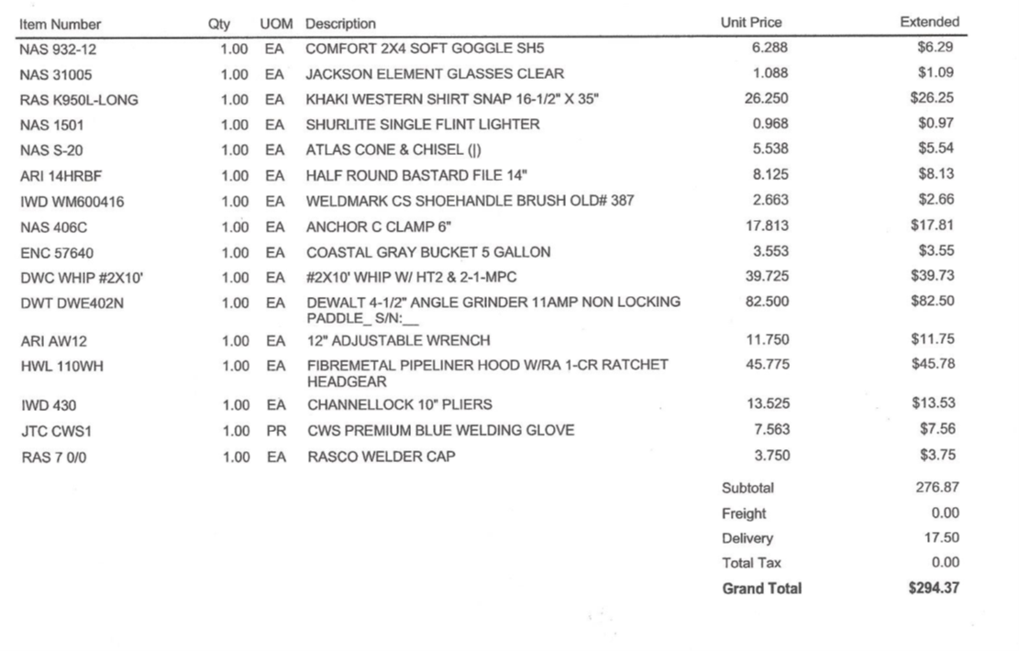

TIG Supply List

These supplies are needed in the final month of class

