1. Go to Lamarpa.edu

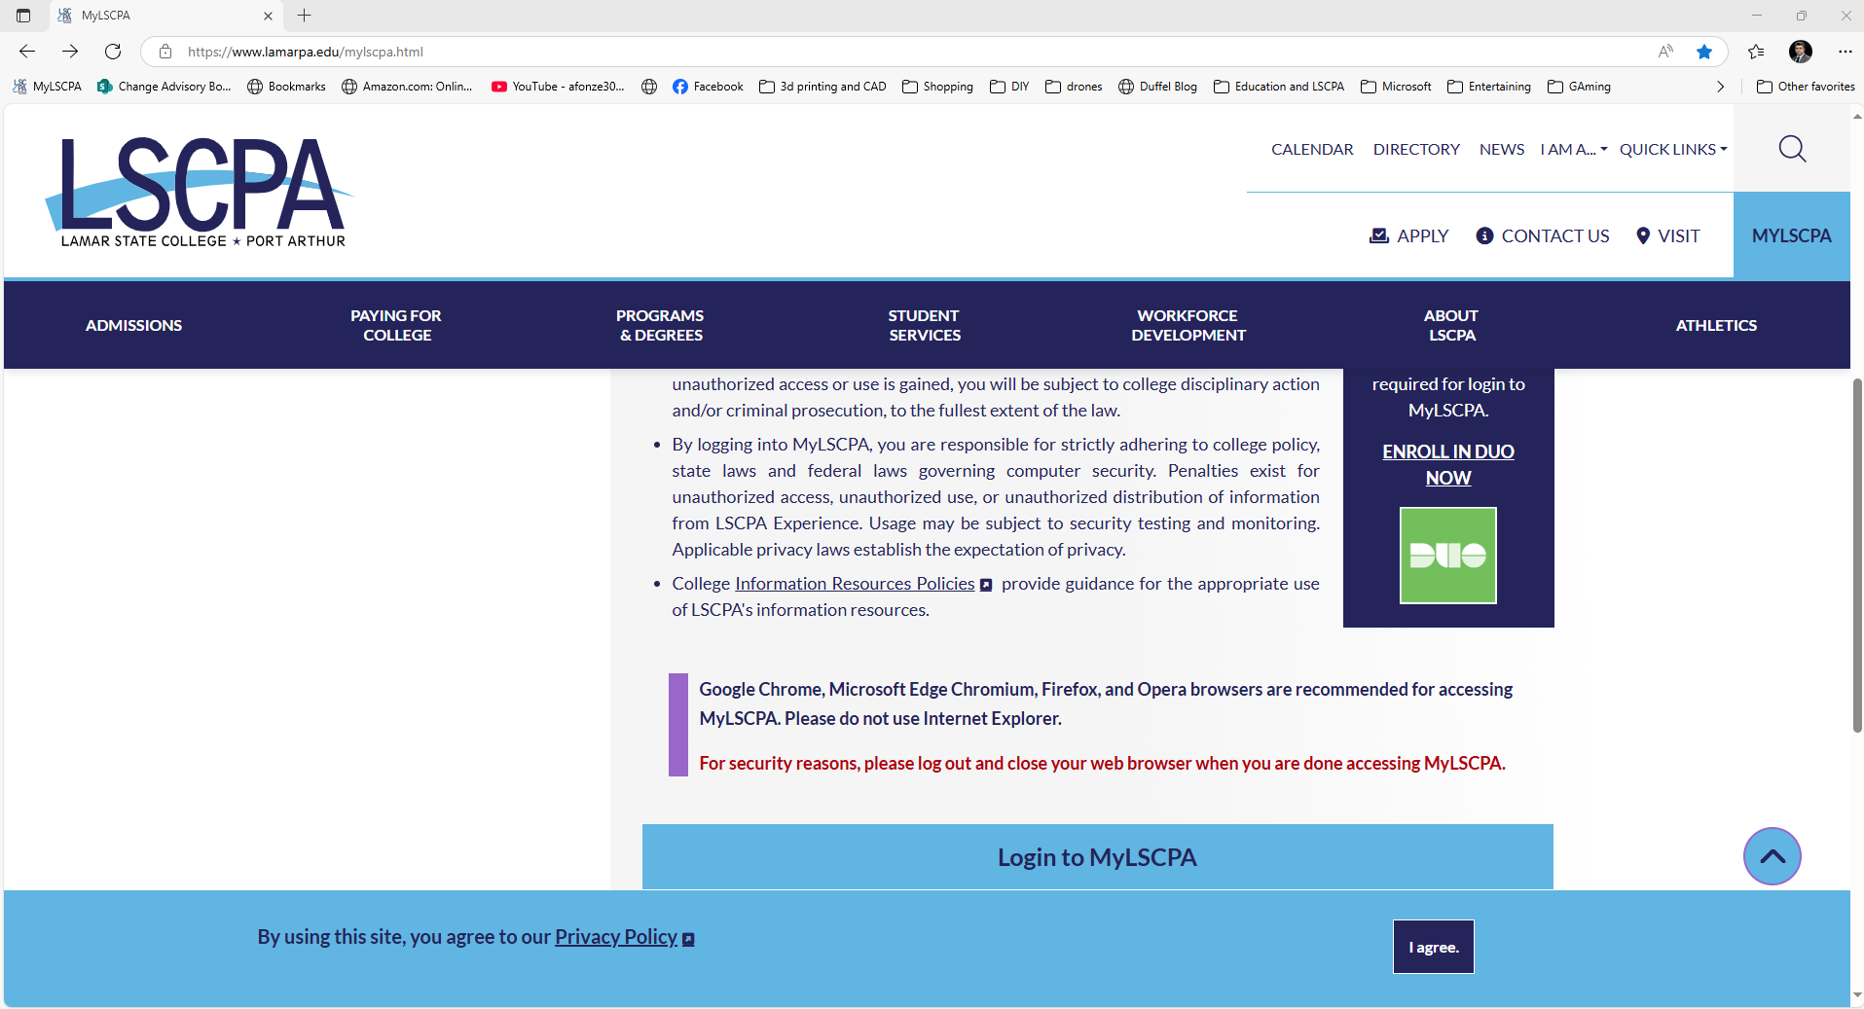



1. Click MYLSCPA to login to the student’s account.
2. Once the student is logged in and can see the Ellucian page with all of the cards, they should scroll till they see Email and Documents, click this card.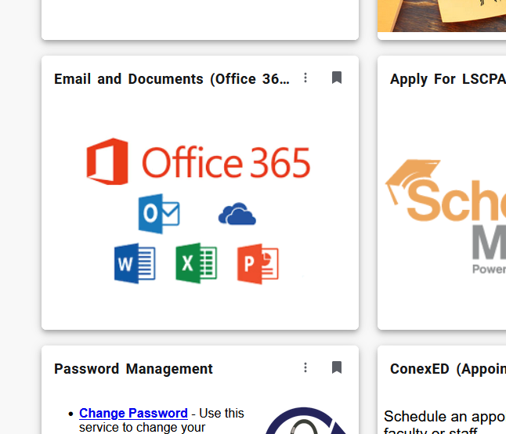



1. Now they should be in the Outlook web version. Click the menu buttons next to the word “Outlook”.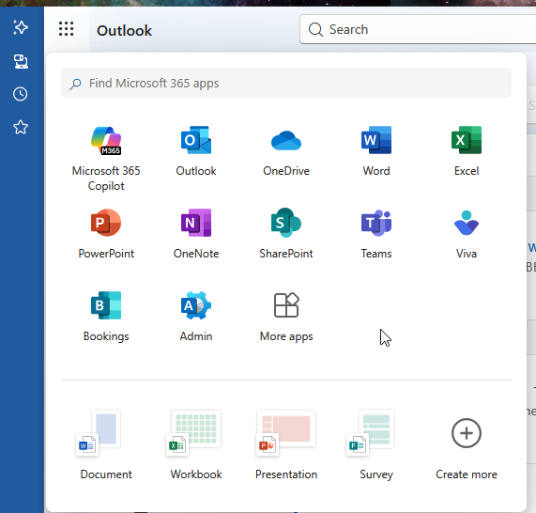



1. Then click the “More apps” icon. That will bring them to the “Apps” page.
2. In the upper right corner, they should see 



1. If they click this, they will see options on what to download. They will want to download the Microsoft 365 appsA screenshot of a computer

   AI-generated content may be incorrect.

They will be prompted to log in again

Download the “Office apps & Devices by

Clicking the “Install Office” button.



It will start the download. Once it is done, they can click on it and it will start installing the Office suite.